1)

2)

3)

Applicants Name Program(s) you are applying for
(In order of preference)

Application Checklist Review
- Completed and Signed Application Form
- Official CLC Eligibility Document – Proof of completing require course work
- 2 Professional Reference Letters – school, work or volunteer
- 1 Personal Reference Letter
- Resume/Curriculum Vitae
- Essay Questions
- Official Documentation of Volunteer Hours

I attest that the information in this application is true and accurate to the best of my knowledge.

Signature: Date:

SUBMITTING YOUR APPLICATION:
Completed applications should be emailed directly to the morelandccls@gmail.com
DO NOT MAIL YOUR APPLICATION TO THE CHILD LIFE COUNCIL OFFICE.

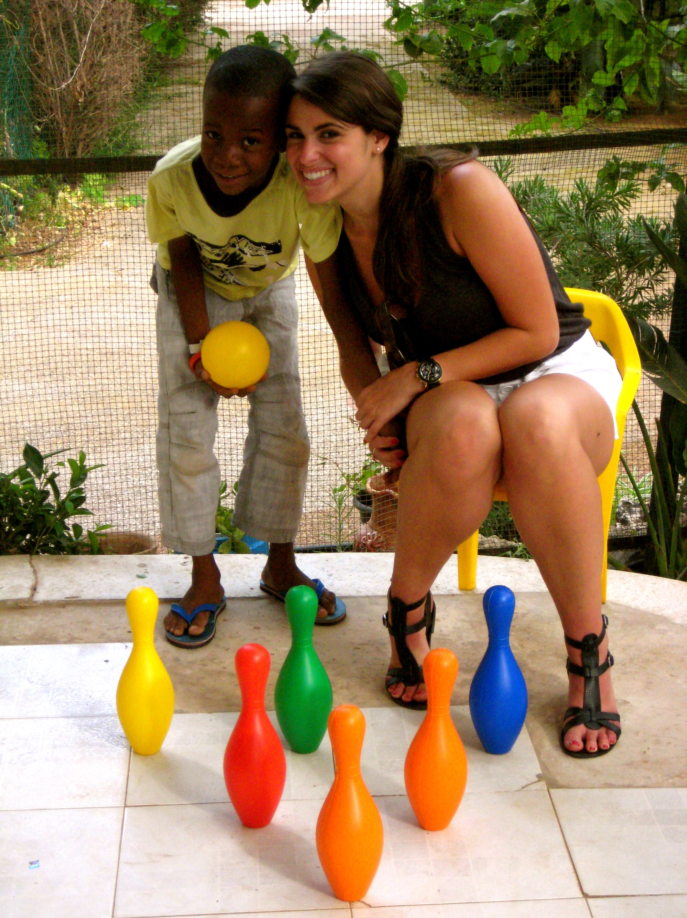

Personal Information

Last Name First Name (M.I.)

Present Phone Permanent Phone Email Address

Present Address Permanent Address

City State/Province ZIP Code Country City State/Province ZIP Code Country

Emergency Contact
In case of emergency, notify:

Name Relationship Address

Home Phone Work Phone City State/Province ZIP Code Country

University Name University Department Address

Language
(Note: Please list ALL the languages you speak and your degree of skill)

Primary Language/First Language

Other Languages you speak:

1. ❑Learning ❑Basic ❑Fluent

2. ❑Learning ❑Basic ❑Fluent

3. ❑Learning ❑Basic ❑Fluent

TOTAL HOURS with Infants, Children, Youth and/or Families in Healthcare Settings:
(Include hours from any additional experiences on page 8.)

Experience with Infants, Children, Youth, and/or Families in Healthcare Settings
(e.g., volunteer, practicum student)

Institution Position Title (e.g., volunteer, practicum student)

May we contact?
Supervisor’s Name and Credentials Supervisor’s Title ❑Yes ❑No

to
Dates (mm/year) Hours/Week # of Weeks Total Hours Completed Supervisor’s Phone Briefly describe population and responsibilities: (approx. 100 word limit)

Institution Position Title (e.g., volunteer, practicum student)

May we contact?
Supervisor’s Name and Credentials Supervisor’s Title ❑Yes ❑No

to
Dates (mm/year) Hours/Week # of Weeks Total Hours Completed Supervisor’s Phone Briefly describe population and responsibilities: (approx. 100 word limit)

Institution Position Title (e.g., volunteer, practicum student)

May we contact?
Supervisor’s Name and Credentials Supervisor’s Title ❑Yes ❑No

to
Dates (mm/year) Hours/Week # of Weeks Total Hours Completed Supervisor’s Phone Briefly describe population and responsibilities: (approx. 100 word limit)

Experience with Infants, Children, Youth, and/or Families in Stressful Situations
(e.g., camps for children with chronic illnesses, programs for children with special needs, advocacy programs, bereavement/hospice experiences)
Organization/Employer

Position Title (e.g., volunteer, practicum student)

May we contact?
Supervisor’s Name Supervisor’s Title ❑Yes ❑No

to
Dates (mm/year) Hours/Week # of Weeks Total Hours Completed Supervisor’s Phone Briefly describe population and responsibilities: (approx. 100 word limit)

Organization/Employer Position Title (e.g., volunteer, practicum student)

May we contact?
Supervisor’s Name Supervisor’s Title ❑Yes ❑No

to
Dates (mm/year) Hours/Week # of Weeks Total Hours Completed Supervisor’s Phone Briefly describe population and responsibilities: (approx. 100 word limit)

Organization/Employer Position Title (e.g., volunteer, practicum student)

May we contact?
Supervisor’s Name Supervisor’s Title ❑Yes ❑No

to
Dates (mm/year) Hours/Week # of Weeks Total Hours Completed Supervisor’s Phone Briefly describe population and responsibilities: (approx. 100 word limit)

TOTAL HOURS with Well Infants, Children, Youth and/or Families:
(Include hours from any additional experiences on page 10.)

Experience with Well Infants, Children, Youth, and/or Families
(e.g., nanny, counselor, teacher)

Organization/Employer

Position Title (e.g., nanny, counselor, teacher)

May we contact?
Supervisor’s Name Supervisor’s Title ❑Yes ❑No

to
Dates (mm/year) Hours/Week # of Weeks Total Hours Completed Supervisor’s Phone Briefly describe population and responsibilities: (approx. 100 word limit)

Organization/Employer Position Title (e.g., nanny, counselor, teacher)

May we contact?
Supervisor’s Name Supervisor’s Title ❑Yes ❑No

to
Dates (mm/year) Hours/Week # of Weeks Total Hours Completed Supervisor’s Phone Briefly describe population and responsibilities: (approx. 100 word limit)

Organization/Employer Position Title (e.g., nanny, counselor, teacher)

May we contact?
Supervisor’s Name Supervisor’s Title ❑Yes ❑No

to
Dates (mm/year) Hours/Week # of Weeks Total Hours Completed Supervisor’s Phone Briefly describe population and responsibilities: (approx. 100 word limit)

Essay Questions

Please answer the following questions:
Why are you interested in an international Child Life practicum/volunteer experience?
Have you ever been out of your home country before? If yes, briefly explain this experience(s)
(approx. 200 words)

What have you done to increase your knowledge/awareness of this profession? (approx. 200 words)

Briefly describe the ways in which the work of a child life specialist contributes to the health care experience of a child and his/her family. (approx. 200 words)

Provide a specific example of a time that you used play to meet the developmental needs of a child. (approx. 200 words)

Please list the names of any professional organizations you are a member of:

The following sections are for completion ONLY if additional space is required for the applicant’s listing of academic information and/or experiences with children and/or families.

Academic Information, continued
(Note: Please list ALL colleges/universities attended.)

2.
College/University Name City, State/Province

to
Dates Attended (mm/year) Graduation Date (mm/year) Major

Level (check one): ❑Bachelor’s ❑Master’s

GPA Cum GPA in Major

3.
College/University Name City, State/Province

to
Dates Attended (mm/year) Graduation Date (mm/year) Major

Level (check one): ❑Bachelor’s ❑Master’s

GPA Cum GPA in Major

4.
College/University Name City, State/Province

to
Dates Attended (mm/year) Graduation Date (mm/year) Major

Level (check one): ❑Bachelor’s ❑Master’s

GPA Cum GPA in Major

Experience with Infants, Children, Youth, and/or Families in Healthcare Settings, continued

Institution Position Title (e.g., volunteer, practicum student)

May we contact?
Supervisor’s Name and Credentials Supervisor’s Title ❑Yes ❑No

to
Dates (mm/year) Hours/Week # of Weeks Total Hours Completed Supervisor’s Phone Briefly describe population and responsibilities: (approx. 100 word limit)

Institution Position Title (e.g., volunteer, practicum student)

May we contact?
Supervisor’s Name and Credentials Supervisor’s Title ❑Yes ❑No

to
Dates (mm/year) Hours/Week # of Weeks Total Hours Completed Supervisor’s Phone Briefly describe population and responsibilities: (approx. 100 word limit)

Institution Position Title (e.g., volunteer, practicum student)

May we contact?
Supervisor’s Name and Credentials Supervisor’s Title ❑Yes ❑No

to
Dates (mm/year) Hours/Week # of Weeks Total Hours Completed Supervisor’s Phone Briefly describe population and responsibilities: (approx. 100 word limit)

Experience with Infants, Children, Youth, and/or Families in Stressful Situations, continued
(e.g., camps for children with chronic illnesses, programs for children with special needs, advocacy programs, bereavement/hospice experiences)

Organization/Employer Position Title (e.g., volunteer, practicum student)

May we contact?
Supervisor’s Name Supervisor’s Title ❑Yes ❑No

to
Dates (mm/year) Hours/Week # of Weeks Total Hours Completed Supervisor’s Phone Briefly describe population and responsibilities: (approx. 100 word limit)

Organization/Employer Position Title (e.g., volunteer, practicum student)

May we contact?
Supervisor’s Name Supervisor’s Title ❑Yes ❑No

to
Dates (mm/year) Hours/Week # of Weeks Total Hours Completed Supervisor’s Phone Briefly describe population and responsibilities: (approx. 100 word limit)

Organization/Employer Position Title (e.g., volunteer, practicum student)

May we contact?
Supervisor’s Name Supervisor’s Title ❑Yes ❑No

to
Dates (mm/year) Hours/Week # of Weeks Total Hours Completed Supervisor’s Phone Briefly describe population and responsibilities: (approx. 100 word limit)

Experience with Well Infants, Children, Youth, and/or Families, continued

Organization/Employer Position Title (e.g., nanny, counselor, teacher)

May we contact?
Supervisor’s Name Supervisor’s Title ❑Yes ❑No

to
Dates (mm/year) Hours/Week # of Weeks Total Hours Completed Supervisor’s Phone Briefly describe population and responsibilities: (approx. 100 word limit)

Organization/Employer Position Title (e.g., nanny, counselor, teacher)

May we contact?
Supervisor’s Name Supervisor’s Title ❑Yes ❑No

to
Dates (mm/year) Hours/Week # of Weeks Total Hours Completed Supervisor’s Phone Briefly describe population and responsibilities: (approx. 100 word limit)

Organization/Employer Position Title (e.g., nanny, counselor, teacher)

May we contact?
Supervisor’s Name Supervisor’s Title ❑Yes ❑No

to
Dates (mm/year) Hours/Week # of Weeks Total Hours Completed Supervisor’s Phone Briefly describe population and responsibilities: (approx. 100 word limit)

